Fault-Tolerant Routing
in Star Graph
with Safety Vectors

Created by: Seng-I Yeh
Date: Jan. 6, 2000

Outline

- Hypercube & Star Graph
- Fault-Free Routing
- Safety Vectors in Hypercube
- Safety Vectors in Star Graph

Hypercube & Star Graph
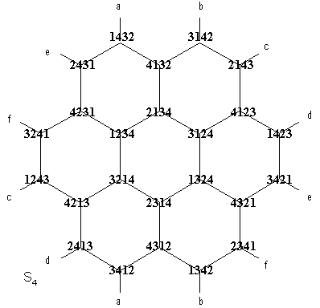
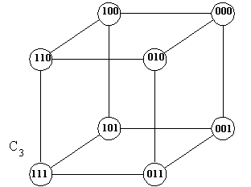

 | n-cube | n star
size | 2^{n} | n!
digree | n | n-1
diameter | n | ⎣3(n-1)/2⎦
average distance | n/2 | n+2/n+H_{n}-4
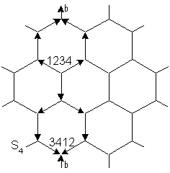
Fault-Free Routing
- Hypercube
0001→1001→1011→1010→1110
- Star Graph
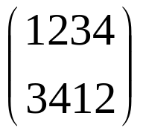 1234 3214 4213 2413 3412
= (13)(24) →(24) →(243) →(43) →( )
2134 4132 1432 3412
→(2413) →(413) →(13) →( )
4231 2431 1432 3412
→(4213) →(213) →(13) →( )
Safety Vectors in Hypercube (part I)

- u_{k} = 0, 1≤ k ≤ n, if u is a faulty node
One end of a faulty link treats the other end as a faulty node.
- Base for first bit:
u₁ = 0 if node u is an end of a faulty link
1 o.w.
- 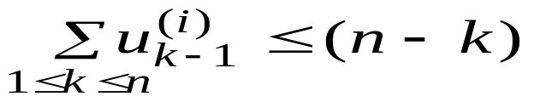 Inductive definition for the kth bit:
u_{k} = 0 if
1 o.w.
Safety Vectors in Hypercube (part II)
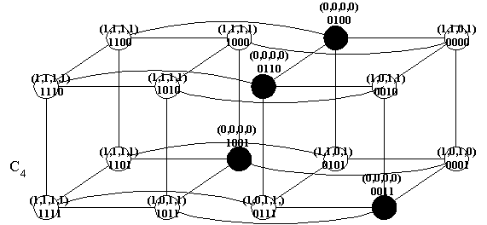
k ← k+1 ← k+2 ← k+3 ← k+4 ← k+5
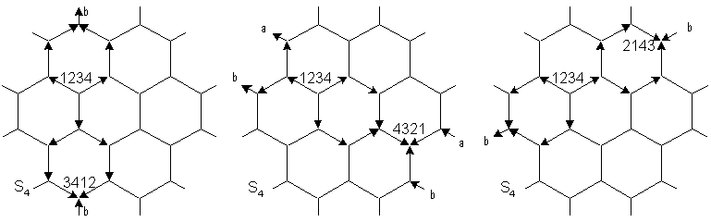
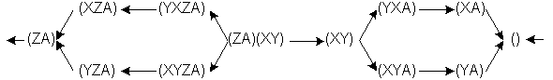
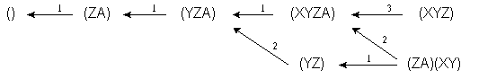
Safety Vectors in Star Graph (part I)
Safety Vectors in Star Graph (part II)
- u_{d,q} = 0, ∀d,q, if u is a faulty node
One end of a faulty link treats the other end as a faulty node.
- Base for first bit:
u₁ = 0 if node u is an end of a faulty link
1 o.w.
- Inductive definition for the pattern-q-bit:
u_{d,q} = 1 if
0 o.w.
p(q): prefered next cycle-pattern of cycle pattern q, n(u): neighbors of node u
c_{q}(q’): number of ways to get cycle-pattern q’ from q
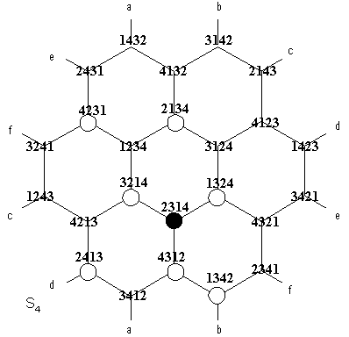
Safety Vectors in Star Graph (part III)
